“WALK FOR A CAUSE” - FEMALE FOETICIDE
National Service Scheme (NSS) of Sri Aurobindo College (M) organized an event “ Walk For a Cause” on Female Foeticide with the collaboration of Forum of obstetricians and Gynecologists of South Delhi and Madhukar Rainbow Hospital on 2nd January 2019. The event was about saving the girl child. Girl child is the most precious human being in the world. “Smiling face of every little girl is the signature of God’s presence.” On this occasion our college principal Dr. Vipin Aggarwal said that women are the most important section of the society and equally participate in the life existence on the earth. It is very necessary to save girl child in order to maintain the ratio of women in India. To create awareness about the Female Foeticide among the local public a rally was conducted by the faculty and staff members of the college and NSS volunteers and Rainbow Hospital Doctors and other staff members from hospital to Malyiya Nagar Market and Sri Aurobindo College premises. The rally did attract a lot of attention from the public as they were curious about female feticide and save girld child. During the rally students chanted various slogans to save girl. A zumba session was also organized by Madhukar Rainbow Hospital in the starting of the programme to enthusiasm the participants. All the NSS volunteers have participated in large numbers and enthusiasm. The event was a great success.
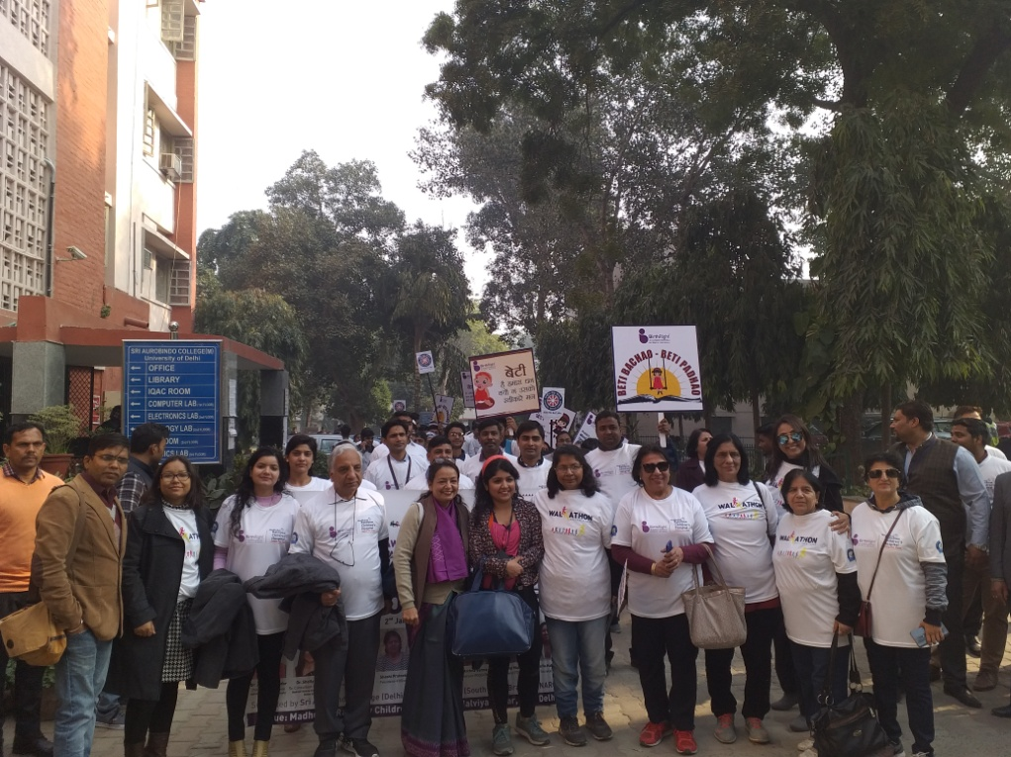
At Sri Aurobindo College Premises
